Name: Date: _________ Hr: _____ Stud. #: _____

Chemistry Fall Final Review HONORS – 2015
Soon you will be embarking on your first semester chemistry final. This is your study GUIDE. It is a guide and not all-inclusive, but if you answer AND UNDERSTAND the following outline points you will be in good shape.
On the day of the final be sure to bring:

- Calculator (I will not be giving out extras if you forget yours!)
- Pencil
- PERIODIC TABLE - Laminated

- Note Card – THIS IS REQUIRED… ONE HAND-WRITTEN (both sides) 3x5 note card. You MUST turn in this note card with your final, if you do not then YOU WILL LOSE 10% off your final exam grade.

UNIT 1: The Wave Nature of Matter: Chapter 1, 2, and 5.3
- Learning Target 1.1: Know what chemistry is.
- What is Chemistry? What do chemists study?

- What is matter? What are some examples of things that are and are not matter?

- Learning Target 1.2: Identify classroom and safety procedures as well as common lab equipment
- What are three things you need to be sure to do/wear to be safe for every lab?

- Learning Target 1.3:Apply the steps of the scientific method and know a science theory compared to a law
- What is a hypothesis and how should it be written?

- Describe the difference between a dependent variable and independent variable.

- What is a trial? Be able to determine how many take place in an experiment.

- Learning Target 1.4: Classify matter as an element, compound, or mixture.
- What are elements and compounds?

- Learning Target 1.5: Compare and contrast physical and chemical properties/changes
- What are the five signs that a chemical change has occurred?

- Learning Target 3.5: Describe and calculate wavelength and frequency for the electromagnetic spectrum
- What is the electromagnetic spectrum?

- What is the wavelength of radiation with a frequency of 4.6×10¹⁵ Hz?

- How much energy is transmitted by a wave that has a wavelength of 4.88 x 10⁻⁷m?

UNIT 2: The Atom and its Particles: Chapters 4 and 5
- Learning Target 3.1: Describe an atom and the subatomic particles
- What is an atom made up of? Where are each of these subatomic particles located?

- How do you utilize the Periodic Table to determine number of protons, neutrons, and electrons?

- How do you determine the number of neutrons in an atom?

- Learning Target 3.2: Recognize contributions various scientists have made to chemistry
- What was the significance of The Double Slit Experiment? The Gold Foil Experiment?

- Learning Target 3.3: Know what an isotope is and how to calculate the average atomic mass
- Define what an isotope is.

- What is the weighted atomic mass of an unknown element with the composition of 50% ⁴⁵X, 36% ⁴⁶X, and 14% ⁴⁷X?

UNIT 3- Locating Electrons: Chapter 5
- Learning Target 3.1, 3.2, & 3.3: Know how to complete orbital diagrams (the ones with arrows) and electron configurations correctly
- List the correct order of atomic orbitals in an orbital diagram/electron configuration.

- Draw the Orbital diagram (arrows) for Uranium (U).

- How does one determine the number of valence electrons?

- Write the full electron configuration and short hand electron configuration for Francium (Fr).

- How many electrons can each individual orbital hold? s _____; p _____; d _____; f _____
- Write the long-hand electron configuration and orbital diagram (Aufbau) for Ta (73).

- Learning Target 3.6: Know the theory and principles that involve the Quantum Mechanic model of the atom
- What is the significance of the Photoelectric Effect?
The Heisenberg Uncertainty Principle?

- Describe what the quantum mechanical model of an atom looks like (s,p,d,f orbitals).

- Learning Target 3.7: Interpret a graph from Photoelectron Spectroscopy to identify the location of electrons.
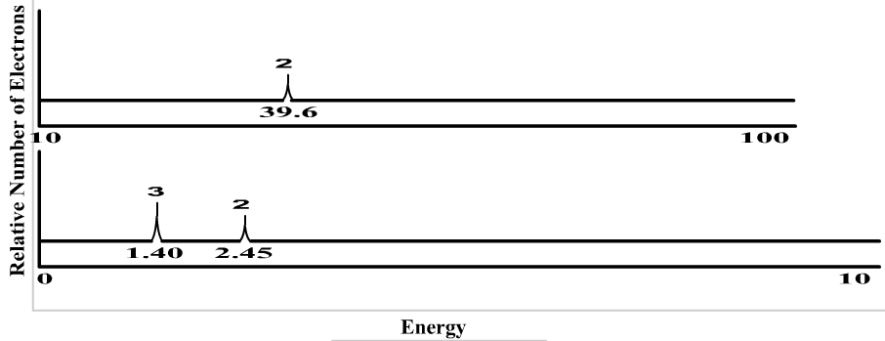
- In the graph to the left, identify which peak represents elements in the 1s, 2s, and 2p orbitals.

- Identify the element shown in the graph.

UNIT 4: The Periodic Table: Chapter 6
- Learning Target 4.1: Explain how elements are organized in a periodic table
- What are the three types of elements?
- Where are they located on the periodic table?

- What are periods? What are groups/Families?

- Learning Target 4.2: Compare early and modern periodic tables
- Who was the first to organize the periodic table? How was it organized?

- How is the periodic table organized now?
- Learning Target 4.3: Identify the different group/families in the periodic table and their characteristics
- Describe the characteristics and where the following families are located:

  - Alkali metals
  - Alkaline earth metals
  - Halogens
  - Noble gases
  - Transition metals

- Learning Target 4.4: Explain what an ion is and how it forms
- What is an ion?

- What type of ions do metals tend to form? Nonmetals?

- Learning Target 4.5: Describe the different periodic trends
- What is atomic size? Know how it increases/decreases across and down the periodic table.

- What is ionization energy? Know how it increases/decreases across and down the periodic table.

- What is electronegativity? Know how it increases/decreases across and down the periodic table.

- Learning Target 4.6 (HONORS): Show how ions form by writing ionization equations
- What is the ionization equation for nitrogen? – Electrons gained are written as REACTANTS and electrons lost are written as PRODUCTS

UNIT 5: Ionic Compounds: Chapters 7, 8, and 9
- Learning Target 5.1: To be able to count the number of atoms in a compound
- How many atoms are in the compound Al(H₂PO₄)₃?

- Learning Target 5.2: Know what an ionic compound is, how to write the chemical formula, and name them
- What type of elements make up an ionic compound? &
- What is a polyatomic ion?

- What are Lewis structures and what are they used to represent?

- What is the chemical formula for the following:
  - Sodium Sulfite ___________________________
  - Copper (II) Phosphate ___________________________
  - Iron (III) Carbonate ___________________________
- Name the following compounds. If the compound involves a metal that can have different charges, then give the STOCK and CLASSICAL name for that compound :
  - Al(H₂PO₄)₃ _________________________________________
  - Cu₂SO₃ _________________________________________
  - (NH₄)₃PO₄ _________________________________________
- Learning Target 5.3: Know what a metallic compound is.
- What type of elements make up a metallic compound?

- Learning Target 5.4 (HONORS): Know how to name a hydrate and acid
- Name the following hydrates/acids
  - CuSO₄ • 5H₂O_________________________
  - BaCl₂ • 2H₂O _________________________
  - H₂S _________________________
  - H₂SO₄ _________________________
UNIT 6: Covalent Compounds: Chapters 7, 8, and 9
- Learning Target 6.1: Know what a molecular (covalent) compound is, how to write the chemical formula, and name them
- What type of elements make up a molecular compound? ____________________ and ___________________________
- BONUS: What is the structural formula for CCl₄? SO₃?

- Name the following molecular compounds:

  - CO ____________________________________________

  - N₂O₂ ____________________________________________

  - PCl₃ ____________________________________________

- Learning Target 6.2: Sketch Molecular structures for covalent compounds
- Learning Target 6.3: Determine if a compound is nonpolar covalent, polar covalent, or ionic
Use the table bellow to answer the following three questions:
Bonding Pairs | Non-Bonding Pairs | Molecular Shape
4 | 0 | Tetrahedral
3 | 1 | Pyramidal
2 | 2 | Bent
1 | 3 | Linear

- Draw the structural formula (with the dashes) of I₂ and give the shape of the molecule. Describe whether the BONDS on the central atom are polar or nonpolar. Then tell whether the overall molecule is polar or nonpolar.

- Draw the structural formula (with the dashes) of PF₃ and give the shape of the molecule. Describe whether the BONDS on the central atom are polar or nonpolar. Then tell whether the overall molecule is polar or nonpolar.

- Learning Target 6.4: Know the advanced molecular geometry
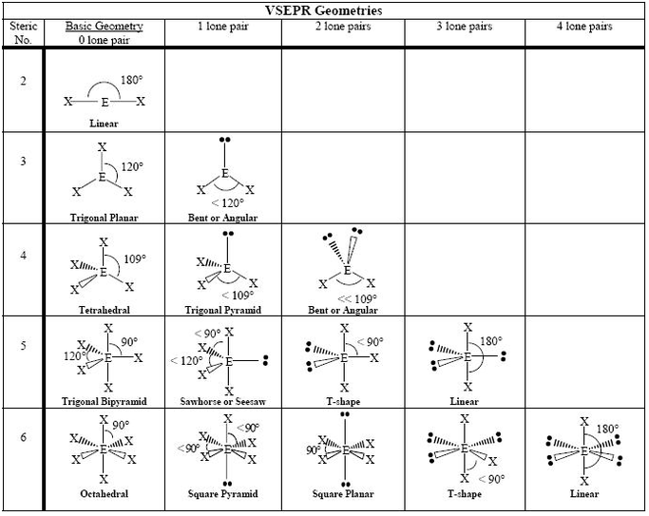
Identify the molecular structure for CH₄ ______________________
Identify the molecular structure for NO₂ ______________________
Identify the molecular structure for XeF₄ (this is the first compound made from a Nobel gas) HINT: It will have 4 bonding pairs and 2 non bonding pairs.
  - DRAW the Structure of XeF₄

MORE – Fall Semester Chemistry Practice Problems:
Free Response: What you need to know:

c = 3 x 10⁸m/s h = 6.63 x 10⁻³⁴ J * s
- What is the frequency, in Hz, of electromagnetic radiation that has a wavelength of 0.55m?

Variables: Formula:

Work:

Answer
w/ units

- 13. What is the energy of a photon that has a frequency of 4.8 x 10¹⁴ Hz?

Variables: Formula:

Work:

Answer
w/ units

- Know how to calculate the average atomic weight of an isotope:
Example: A Sample of Iodine (I) contains: 80% ¹²⁷I; 17% ¹²⁶I, and 3% ¹²⁸I. Calculate the average atomic mass of the Isotope of Iodine! (Don’t forget to use the units AMU’s for masses).

- Write the electron configuration and orbital diagram (with arrows) for the element Silver (Ag).

- Write the e- configuration for Aluminum ion (Al⁺³)

- Draw the Lewis Dot structures for the following elements:

  - Mg b. P c. Br d. K e. S

- BONUS: Draw the structural Formula (Lewis Dot structure) (dashes for bonded electrons, dots for unbounded electrons) and identify the shape for the following covalent molecules:

  - CO₂

  - PF₃

  - H₂CO

  - SiCl₄

  - SI₂

  - HCl

5. Name the following Compounds:

- Al₂S₃
- Al₂(SO₄)₃
- BaCO₃
- Cu(C₂H₃O₂)
- FePO₄
- N₂O₅
_{h.} Pb(ClO₄)₄

6. Write the Formula for the following Compounds: (For Ionic Compounds – Show charges and Criss-Cross)
a. Magnesium Nitrate
b. Manganese (II) Nitrite
c. Ammonium Sulfide
d. Tricarbon tetraoxide
e. Tin (II) Phosphide
f. Pentasulfur Octonitride
g. Carbon Hexoxide
H. Calcium Fluoride

7. Determine the number of protons, neutrons, and electrons for the isotope of element Fe-55⁺³.
a. Number of protons: . b. Number of neutrons: . c. Number of electrons:
8. Write the name of the following Groups found on the Periodic Table:

- Group 7A Elements -
- Group 8A elements -
- Group 1A elements -
- Group 2A elements -

Metals are found on the side on the periodic table, and nonmetals are found on the side of the periodic table.
10. Parts of the Scientific Method: Hypothesis; Theories, Variables (Independent Variable (what you do/change); (Dependent Variable – what you measure); experiments. etc…

11. Periodic Trends:

- Size of Atom
- Electronegativity
- Ionization Energy

