Colligative Properties: The Influence of a Solute

- ____________________________: the properties that deal with the ___________ of particles dissolved in a given mass of solvent
The physical properties of a solution differ from the properties of the solvent
  - Vapor Pressure __________________
  - Boiling Point _________________
  - _____________________ Point Depression
i = the Van’t Hoff factor,
- i = the number of particles into which the added solute __________________
- for ALL molecular compounds, the Van’t Hoff factor is equal to _______
- for ionic compounds (that _________________ dissolve in the solvent), the Van’t Hoff factor is dependent upon the ___________ of particles dissociated once dissolved
Examples
- NaCl →
- Van’t Hoff factor = _____
- Na₃PO₄ →
- Van’t Hoff factor = _____
- For colligative properties, the _____________ of the particles IS NOT IMPORTANT.
- Size and molar mass do NOT matter – the number of the ________________ particles is what is important here!
Vapor Pressure Lowering
- Vapor Pressure: the pressure exerted by a ______________ that is in dynamic equilibrium with its ____________ in a closed system
- When solutes are added to a pure solvent, the vapor pressure is ____________________
  - ______________ ______________ molecules escape liquid phase
  - The decrease is proportional to the number of solute _______________ dissolved
- Vapor Pressure decreases when a _______________ solute is added to a solvent
SKETCH

- Vapor Pressure increases when a _______________ solute is added to a solvent
Effect on Boiling Point
- Boiling Point _______________________: When a nonvolatile solute is added to a solution the boiling point of the solution will ________________.
- Boiling Point: the temperature where the vapor pressure of the liquid _______________ atmospheric pressure
- When solute is added, the vapor pressure is ________________ so the boiling temperature is ___________________
- Additional _____________ __________ is required to break apart solute/solvent interactions
- http://www.chem.purdue.edu/gchelp/solutions/eboil.html
Sketch/Summarize

Boiling Point Elevation
- Occurs because additional solute particles __________________ vapor pressure so more pressure is needed to boil
- More energy is needed to break _______________ ________ between neighboring molecules and exert additional vapor pressure

Freezing Point Depression: Temperature difference between the freezing point of _____________ and pure _____________
- Solutes _______________ the normal geometric pattern of a pure frozen solvent in a solution
- Additional ________________ energy must be lost for ________________________ to occur
SKETCH

Practice Problems
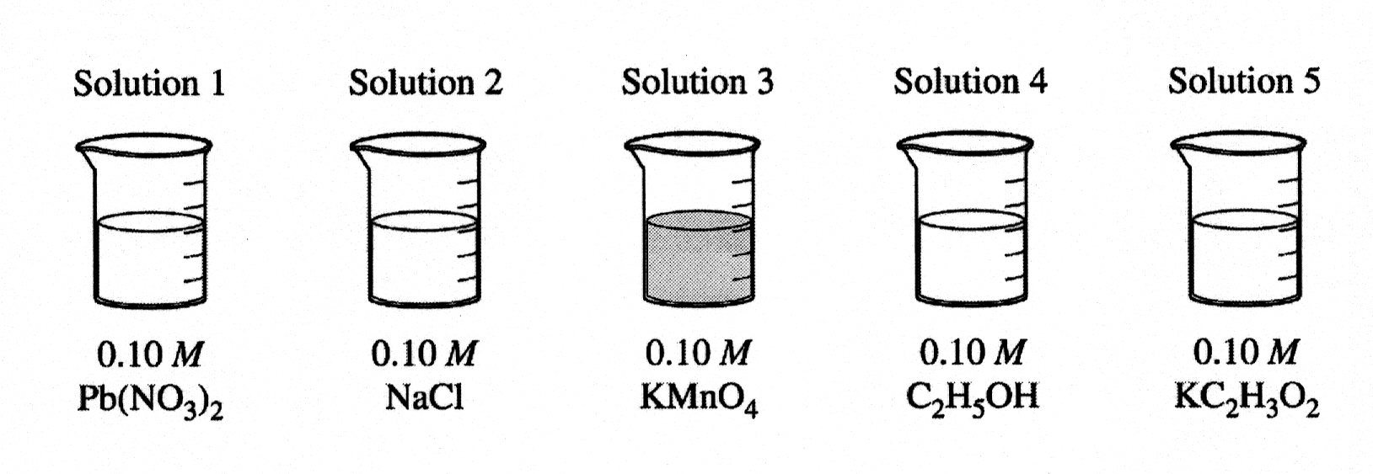
a. Which solution has the highest boiling point? Explain.

b. Which solution has the lowest vapor pressure? Explain.

c. Identify a pair of the solutions that would produce a precipitate when mixed together. Write the formula of the precipitate.

d. When KMnO₄ is used to oxidize hydrogen peroxide, what is the oxidation state of the Mn in KMnO₄ and in the product, Mn²⁺?

e. Which solution would be the least effective conductor of electricity due to its lack of charged particles? Explain.

