Name:___________________________

Period:__________________________

**Chemistry Unit 10 – Moles**

**Unit Objectives**

|  |  |
| --- | --- |
| **Honors**  **(5.0)** | All of Levels 3 and 4 as well as…   * Use combustion analysis and an experimental molar mass to determine both the empirical and molecular formulas for a hydrocarbon. |
| **More Complex (4.0)** | All of Level 3 and…   * Using either percent or grams of each element, calculate the empirical and molecular formulas of a compound even when the ratios are not whole numbers. |
| **Target Goal (3.0)** | * **Convert amounts between moles, mass, particles, and volume.** * **Describe the percent composition AND use percent to predict the amount of each substance that can be obtained from a compound.** * **Calculate the empirical and molecular formulas when given percent composition.** |
| **Simpler (2.0)** | * Complete one-step and two-step conversions to change between moles, mass, particles, and volume. * Describe the percent composition of a substance from it’s formula. * Calculate simple empirical formulas and molecular formulas when given percent composition. |
| **With Help (1.0)** | All of Level 2 with hints/guidance |

|  |  |  |  |
| --- | --- | --- | --- |
| **Objective** | **Learning Opportunities** | **Suggested Due Date** | **Date Completed** |
| 10.0 Use Dimensional Analysis to solve problems. | * Sig-Figs Review * Read p. answer Qs 38-45 * Podcast: T-Tables * T-table Review and Practice * Unit Conversions with T-Tables | 03/06 |  |
| 10.1 Describe the mole and representative particle relationship using Avogadro’s number. | * Read p. 286-296. * Podcast 6.1 Measuring Amounts of Substances * Answer 3-4 pg. 291, 5-6 pg. 292, 9-14 pg. 296 * Compounds Review Practice Sheet * The Mole and Avogadro’s Number | 03/08 |  |
| 10.2 Identify the relationship between moles and GAM, GFM, and GMM. | * Read p. 293- 299. * Podcast 6.2A Molar Mass * Answer 7,8,15 pg. 296; 16 and 17, p. 298; 18-19 pg. 299; 24, 26, 27 pg. 303 * Gram Formula Mass * Moles Mini Lab * Podcast 6.2B Moles Mini Lab (Watch AFTER Completing the Lab) * Moles and Mass | 03/13 |  |
| 10.3 Describe STP and the relationship between volume of a gas and moles. | * Read p. 300-303. * Podcast 6.3 Molar Volume * Answer 20-21 pg. 301, 22-23 pg. 302, 25, 28-31 pg. 303 * Calculations with Moles Group Assignment * Mixed Mole Problems * Chapter 10 Quiz | 03/15 |  |
| 10.4 Determine percent composition by mass | * Read p. 305-308. * Podcast 6.4 Percent Composition * Answer 32-33, p. 306; 34-35, p. 307; 43 and 44, p. 312 | 03/15 |  |
| 10.5 Identify molar ratios to determine empirical and molecular formulas | * Read p. 309-313. * Podcast 6.5 Empirical Formula and Molecular Formula * Answer 36 and 37, p. 310; 38 and 39, p. 312, 45 and 46, p. 312 * Empirical Formula of a Hydrate Lab * Unit 10 Review | 03/22 |  |
| Unit 10 Test | * Unit 10 Test | 03/24 |  |

**Podcast:** [**Significant Figures**](http://www.showme.com/sh/?h=OSC7Mdk) **“Sig-Figs”**

Measurement Uncertainty

* Measurements in science needs to be _________ (and therefore hopefully ____________)
* Uncertainty on measurements are based upon the _____________________ used
  + 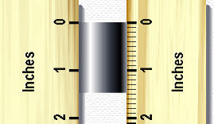Made up of a number of digits that are certain, and one additional digit which represents an estimation

Example: Use a ruler to measure the length of the metal rod.

* Markings for every tenth of an inch
* You can now say the rod is 1.48 inches
  + The ___ and___are the certain numbers
  + The ____ in the hundredth place is the uncertainty digit (based upon ruler provided)

Significant Figures

* ______________ digits in a MEASUREMENT
* Exact numbers are counted, have unlimited significant figures
* _______ _______ except zero are significant.
* Some zeros are, some aren’t…

Which Zeroes Count? The Pacific and Atlantic Technique

* + 3200
  + 3200.
  + 320.0

How many sig figs do the following numbers have?

1. 1.032
2. -0.007
3. 6800
4. 1.30
5. 2.46
6. 10.02
7. 6800.0

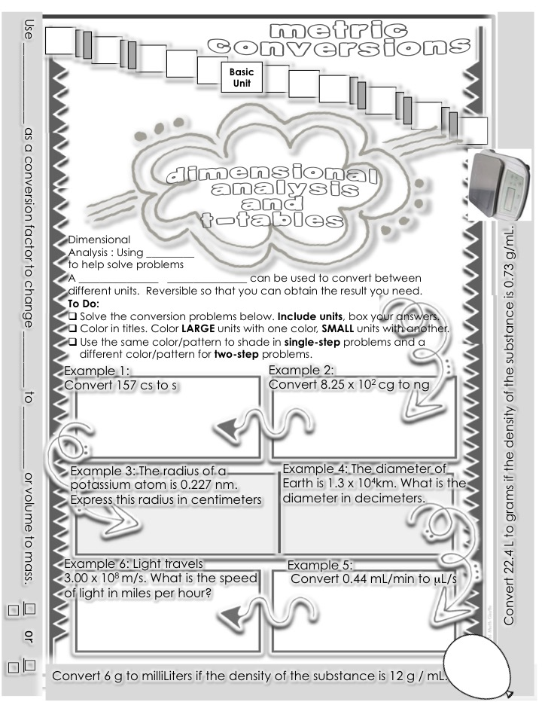

**T-Table Review and Practice**

1. Write the given number and unit.
2. Set up a conversion factor (fraction used to convert one unit to another).
   1. Place the given unit as denominator of conversion factor.
   2. Place desired unit as numerator.
   3. Place a “1” in front of the larger unit.
   4. Determine the number of smaller units needed to make “1” of the larger unit.
   5. Go to base units first (meter, Liter, gram).
3. Cancel units. Solve the problem. A vertical line means multiply (x), whereas a horizontal

line means divide, (*÷*).

Example 1: 55 mm = _____ m Example 2: 88 km = _____m

$\frac{55 mm}{}|\frac{1 m}{1000 m}=0.055 m$ $\frac{88 km}{}|\frac{1000 m}{1 km}=88,000 m$

Example 3: 7000 cm = _____ hm Example 4: 8 daL = _____ dL

$\frac{7000 cm}{}\left|\frac{1 m}{100 cm}\right|\frac{1 hm}{100 hm}=0.7 hm$ $\frac{8 daL}{}\left|\frac{10 L}{1 daL}\right|\frac{10 dL}{1 L}=800 dL$

**Unit Conversions**

1. Convert 20.33 cm to m

|  |  |  |  |
| --- | --- | --- | --- |
| 20.33 cm | 1 m | = 20.33 *1 m | = 20.33 x 10-2 m |
|  | 102 cm | 102 |  |

1. Convert 12.06 L to cL

|  |  |  |  |
| --- | --- | --- | --- |
| 12.06 L | 102 cL | = 12.06 *102  cL | = 1,206 cL |
|  | 1 L | 1 L |  |

1. Convert 32.27 kg to g

|  |  |  |  |
| --- | --- | --- | --- |
| 32.27 kg | 103 g | = 32.27 *103  g | = |
|  | 1 kg | 1 kg |  |

1. Convert 13.09 m to cm

|  |  |  |  |
| --- | --- | --- | --- |
| 13.09 m | 102 cm | = 13.09 *102  cm | = |
|  | 1 m | 1 m |  |

1. Convert 3.47 mm to m

|  |  |  |  |
| --- | --- | --- | --- |
| 3.47 mm | 1 m | = |  |
|  | 103 mm |  |  |

1. Convert 33.81 kg to g

|  |  |  |  |
| --- | --- | --- | --- |
| 33.81 kg | 103 g | = |  |
|  | 1 kg |  |  |

1. Convert 9.92 kL to L

|  |  |  |  |
| --- | --- | --- | --- |
| 9.92 kL |  | = |  |
|  | kL |  |  |

1. Convert 2.61 g to mg

|  |  |  |  |
| --- | --- | --- | --- |
| 2.61 g |  | = |  |
|  | g |  |  |

1. Convert 24.37 g to mg
2. Convert 28.77 L to cL
3. Convert 22.04 mL to L
4. Convert 9.42 L to mL
5. Convert 20.03 cm3 to mL
6. Convert 23.28 L to mL
7. Convert 9.72 mL to L
8. Convert 1.47 kg /m3 to g/cm3

|  |  |  |  |
| --- | --- | --- | --- |
| 1.47 kg | 103 g | 1 m3 | = |
| 1 m3 | 1kg | (100 cm)3 |  |

1. Convert 7.18 mL/min to cL/sec

|  |  |  |  |  |
| --- | --- | --- | --- | --- |
| 7.18 mL | L | cL | 1 min | = |
| 1 min |  | L | ______ sec |  |

1. Convert 33.21 cg to mg
2. Convert 30.62 mg to cg
3. Convert 16.43 mg/hour to cg/s

**Podcast 6.1:** Measuring the Amount of “Stuff”

The Mole

Measuring the Amount of “Stuff”

* Suppose you needed to measure the amount of sand in a child’s sandbox…
* You could count each grain of sand (the number of ______________________)
* You could weigh the sand (_________________)
* You could measure how many bucketfulls of sand there are (_______________________)
* You could use **_________________** to convert the number of particles to mass or to volume and vice versa

It’s kinda like… Cooking!(only we don’t lick the spoon)

**Podcast “How Big is a Mole?”**

1 Mole = ______________________________ particles

Defining particles…

Elements have particles called ______________________

Compounds have particles called _______________________

Moles are like measuring cups

**Mollionaire**

Q: how long would it take to spend a mole of $1 coins if they were being spent at a rate of 1 billion per second?

A:

**Comparing sugar (C12H22O11) & H2O**

|  |  |  |
| --- | --- | --- |
| **Same** | **1 gram each** | **1 mole each** |
| **Volume?** |  |  |
| **Mass?** |  |  |
| **# of Moles?** |  |  |
| **# of Molecules?** |  |  |
| **# of Atoms?** |  |  |

**Podcast: Converting Moles to Particles**

Example: How many moles of magnesium is 1.25 x 1023 atoms of magnesium?

Practice Problems

1. What is Avogadro’s Number?

2. How many moles of sodium is 6.482 x 1023 atoms of sodium?

3. If there are 1.03 x 105 mol cesium, then how many atoms are there?

4. If there are 8.925 x 10-3 mol of sulfur, then how many atoms are there?

5. How many atoms are in 2.12 mol of propane (C3H8)?

6. You have 1.75 mol Ba3(PO4)2

a)What is the name of this compound.

b) How many atoms are there?

7. a) How many moles are there in 1.50 x 1023 molecules of NH3

b)What is the name of this compound?**Podcast 6.2: “Determining the Molar Mass”**

**Molar Mass – Use the Periodic Table**

* The mass of one mole is called “molar mass”
* Example: 1 mol Li = ______________
* This is expressed as ______________

Examples

What are the following molar masses?

S

SO2

Cu3(BO3)2

Calculate molar masses (to 2 decimal places)

1. CaCl2
2. (NH4)2CO3
3. O2
4. Pb3(PO4)2
5. C6H12O6

**Podcast: “What is Molar Mass?”**

Molar Mass – Don’t be fooled by other names!

* Gram Atomic Mass (GAM) – molar mass of an _________________________________

(all atoms are identical)

* Gram Molecular Mass (GMM) – molar mass of a __________________________________________ (atoms that are covalently bonded)
* Gram Formula Mass (GFM) molar mass of an _____________________________________________ (ions bound in specific simple mole ratios)

**Podcast: Converting between Grams and Moles**

* If we are given the # of grams of a compound we can determine the # of moles, & vise-versa
* In order to convert from one to the other you must first calculate molar mass
* Use a t-table to decide which conversion factor to use.

|  |  |  |  |
| --- | --- | --- | --- |
| **Formula** | **Molar Mass**  **(g/mol)** | **Mass**  **(g)** | **Moles**  **(mol)** |
| HCl |  |  | 0.25 |
| H2SO4 |  | 53.15 |  |
| NaCl |  |  | 3.55 |
| Cu |  | 1.27 |  |

**Mole Mass Practice Problems**

1. How many moles are represented by 16.0 g of ethanol, C2H5OH?
2. How many grams of glucose are in 6.63 x 1023 molecules of glucose, C6H12O6?
3. How many moles of methanol, CH3OH, are in 6.53 x 1023 molecules of methanol?
4. How many moles of sodium chloride are in 16.0 g of sodium chloride?
5. How many molecules of potassium hydroxide are in 40.6 g?
6. How many grams of chromic chloride are in 7.14 moles of chromic chloride?

**GRAM FORMULA MASS**

Determine the gram formula mass (the mass of one mole) of each

compound below.

1. KMnO4 ______________________________
2. KCl ______________________________
3. Na2SO4 ______________________________
4. Ca(NO3)2 ______________________________
5. Al2(SO4)3 ______________________________
6. (NH4)3PO4 ______________________________
7. CuSO4 • 5 H2O ______________________________
8. Mg3(PO4)2 ______________________________
9. Zn(C2H3O2)2 • 2 H2O ______________________________
10. Zn3(PO4)2 • 4 H2O ______________________________
11. H2CO3 ______________________________
12. Hg2Cr2O7 ______________________________
13. Ba(ClO3)2 ______________________________
14. Fe2(SO3)3 ______________________________
15. NH4C2H3O2 ______________________________

**The Mole Lab**

**Purpose:** To determine how the number of moles or particles for a specific substance can be determined using Avogadro’s Number and the mass of a substance on the periodic table.

**Hypothesis:** _____________________________________________________________________________

_____________________________________________________________________________

_____________________________________________________________________________

**Materials:** (Indicate only those that you used) _____________________________________________________________________________

_____________________________________________________________________________

_____________________________________________________________________________

Procedure: (If a calculation is required, then you must show your work in your data analysis!)

1. Obtain a Mass measurement for a piece of copper Wire and record it in your data table.
2. Calculate the number of moles in your piece of wire. (Remember that Copper’s Symbol is Cu and all calculations should be shown in data analysis.)
3. Calculate the total number of Copper of atoms that exist in your wire.
4. Gather approximately 1.4 g of Calcium or Aluminum on a watch glass. Record the actual amount of mass that you collected in your data table.
5. Calculate the # of moles of Calcium or Aluminum that you collected.
6. Calculate the # of atoms of Calcium or Aluminum that you collected.
7. Calculate the # of moles and atoms that you should have collected.
8. Calculate your Percent Error for the # moles of Calcium or Aluminum that you collected.
9. Obtain 1.4 g of sodium carbonate.
10. Calculate the # of moles of the sample you collected.
11. Calculate the # of formula units of the sample you collected.
12. Calculate the # of atoms for your sample.
13. Calculate your Percent Error for the # moles of sodium carbonate.

**Data:**

|  |  |  |  |  |  |
| --- | --- | --- | --- | --- | --- |
| Substance | Symbol or Formula | Mass (g) | # of Moles (mol) | Molecules | Atoms |
| Copper |  |  |  |  |  |
|  |  |  |  |  |  |
| Sodium Carbonate |  |  |  |  |  |

**Data Analysis:**

Help with Calculations

Copper Calculations:

Percent Error Calculation:

____________________________________________________________________________________

____________________________________________________________________________________

Calcium or Aluminum Calculations:

Percent Error Calculation:

____________________________________________________________________________________

Sodium Carbonate Calculations:

Percent Error Calculation:

____________________________________________________________________________________

**Comparing amounts:**

Create a Google Slide and insert pictures of the following:

1. One mole of sodium bicarbonate
2. One mole of a metal sample
3. One mole of sugar
4. One mole of sodium chloride

In a well-written sentence or two, compare the amounts of substances shown in your photos. Link or embed the slide(s) on your chemistry page of your website.

**Podcast 6.3: “Molar Volume”**

* Volume varies with a change in temperature of pressure
* The volume of a gas is usually measured at Standard Temperature and Pressure, _________
* **Standard Temperature**: _______oC
* **Standard Pressure**: _________ kPa or 1 atm

Volume at STP

* At STP, 1 mole of any gas fills ___________ L(molar volume of a gas)
* 22.4 L of a gas at STP has ____________ particles

**Podcast: “Molar Density”**

* Density =
* Molar Density will always have the same t-table except for the first square

**Podcast: “Mixed Mole Problems”**

1. How many grams are there in 1.5 x1025 molecules of CO2?
2. What volume would the same CO2 occupy at STP?
3. What is the molar density of CO2 at STP?

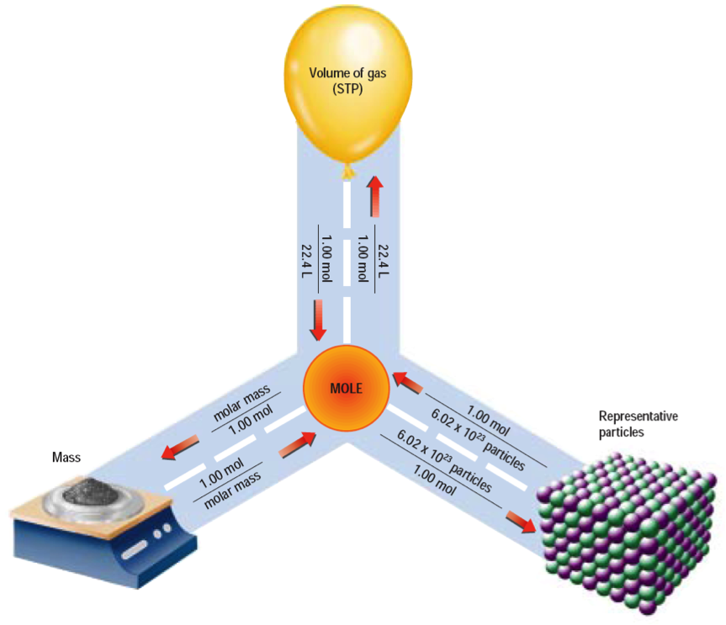

**Podcast 6.4 Percent Composition**

* Percent Composition: The relative amounts of each _____________________________________ in a compound expressed as a percent
* Also called “percent by mass”
* % means “part over whole”

Example 1

8.2 g of Magnesium reacts completely with 5.40 g of Oxygen to form a compound. What is the percent composition of each element in the compound?

If all you are given is the formula or name of a compound, then you must use Molar Mass from the Periodic Table

* Example: Calculate the % composition of propane, C3H8.

Percent Composition can also be used as a conversion to solve for mass.

* Calculate the mass of carbon in 82.0 g of propane C3H8

**Podcast 6.5: Empirical and Molecular Formulas**

Consider NaCl (ionic) vs. H2O2 (covalent)

Sketch each compound

Example 1: Write empirical formulas for the following

1. propene (C3H6)
2. ethene (C2H2)
3. glucose (C6H12O6)
4. octane (C8H14)

Example 2: Identify these as an empirical formula, molecular formula, or both

1. H2O
2. C4H10
3. CH
4. NaCl

Steps to Calculate the Empirical Formula

What is the empirical formula of a compound that is 25.9% nitrogen and 74.1% oxygen?

1. Assume that the % given is equal to the number of grams.
2. Convert the number of grams to moles using GAM.
3. Divide by the lowest number of moles to obtain the simplest whole number ratio
4. If necessary, multiply by a whole number to obtain a whole-number ratio

Empirical Formulas

1. % to Mass
2. Mass to Moles
3. ÷ by small
4. × till whole
5. Write the chemical formula using these whole number ratios

**Podcast: “Molecular Formulas”**

The empirical formula of a compound is CH2. It’s molecular mass is 70 g/mol. What is its molecular formula?