Name:\_\_\_\_\_\_\_\_\_\_\_\_\_\_\_\_\_\_\_\_\_\_\_\_\_\_\_

Period:\_\_\_\_\_\_\_\_\_\_\_\_\_\_\_\_\_\_\_\_\_\_\_\_\_\_

**Chemistry Unit 9 –Reaction Prediction**

**Unit Objectives**

|  |  |
| --- | --- |
| **Honors**  **(5.0)** | All of Levels 3 and 4 as well as…   * Use half reactions to balance complex redox reactions * Calculate the voltage transferred in a redox reaction. |
| **More Complex (4.0)** | All of Level 3 and…   * Predict the products of the decomposition of metal carbonates (or other polyatomic ions) |
| **Target Goal (3.0)** | * **Predict the products formed by chemical reactions.** * **Identify which substance in a reaction has been oxidized/reduced.** * **Determine the solubility of an ionic substance and predict whether a precipitate will form in double replacement reactions.** * **Write net ionic equations.** |
| **Simpler (2.0)** | * Write the chemical formulas of products formed by the basic 4 reactions, acid-base reactions, and the combustion of simple carbohydrates. * Given a half-reaction, tell whether the substance has been oxidized or reduced. * Decide if a substance is soluble (aq) or insoluble (s). * Recognize spectator ions in a complete ionic equation and write the resulting net ionic equation. |
| **With Help (1.0)** | All of Level 2 with hints/guidance |

|  |  |  |  |
| --- | --- | --- | --- |
| Objective | Learning Opportunities | Suggested Due Date | Date Completed |
| 9.1 Predict the Products of Basic Reactions | * Podcasts for Special Types of Reactions * Read p. 337 - 341 * #13-14 pg. 331; #15-16 pg. 332; * Redox Movie * Redox Reactions Crash Course Chemistry #10 | 02/06 |  |
| 9.2 Determine if a Substance is Oxidized or Reduced | * Podcast Predicting Products (Doodle Notes) * Read p. 330 – 337 * Predicting Products in Chemical Reactions * Predicting Products of Reactions Part 1 and Part 2 * Related Reactivities of Metals DEMO | 02/08 |  |
| 9.4 Predict Solubility and Precipitate Formation in Double Replacement Reactions. | * Podcast 7.5A Solubility Rules * Read p. 342 – 344, Answer #30-35 * Drip-Drop Lab Station * Read p. 342 - 344 * #17 pg. 334; #18-19 pg. 335 | 02/10 |  |
| 9.5 Recognize Spectator Ions in Complete Ionic Equations and Write the Net Ionic Equation | * Podcast: Net Ionic Equations (Doodle Notes) * Solubility Rules Quiz * Net Ionic Equations * Copper-to-Copper Lab 02/13 - 02/17 (Digital Portfolio Lab) * Unit 9 Test Review | 02/17 |  |

**Podcast Acid-Base Reactions** <https://goo.gl/rvYaav>

Acid-Base Reactions: A reaction that involves an Acid and a Base as reactants that will always produce \_\_\_\_\_\_\_\_\_\_\_\_ and a \_\_\_\_\_\_\_\_\_\_\_\_\_ as Products.

* + Chemical Formulas for Acids will begin with \_\_\_\_\_\_\_\_\_\_\_\_\_\_\_ (H2SO4 – Sulfuric Acid)
  + Chemical Formulas for Bases will end with \_\_\_\_\_\_\_\_\_\_\_\_\_\_\_\_ (KOH – Potassium Hydroxide)
  + 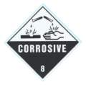Acid-Base Reaction is a specific type of \_\_\_\_\_\_\_\_\_\_\_\_\_\_\_\_\_\_\_\_\_\_\_\_\_\_\_\_\_\_\_\_\_\_ Reactions

Examples

H2SO4 and KOH

HCl and NaOH

* *Note: Acids and Bases are opposites. One is always used to \_\_\_\_\_\_\_\_\_\_\_\_\_\_\_\_\_\_\_\_\_\_ the other.*

**Podcast Combustion Reactions** <https://goo.gl/ey4zBs>

Combustion Reactions: An element or a compound reacts with \_\_\_\_\_\_\_\_\_\_\_\_\_\_\_\_\_\_\_ gas to produce energy in the form of heat and light

* Commonly Involve \_\_\_\_\_\_\_\_\_\_\_\_\_\_\_\_\_\_\_\_\_\_\_\_\_\_\_\_\_\_\_\_\_\_\_\_
* Combustion of Hydrocarbons will ALWAYS produce \_\_\_\_\_\_\_\_\_\_\_\_\_\_\_ and \_\_\_\_\_\_\_\_\_\_\_\_\_\_\_\_\_\_\_\_ as products
* Combustion will stop when \_\_\_\_\_\_\_\_\_\_\_\_\_ supply is used up or the fuel runs out

Examples

C2H5OH – Ethanol or Ethyl Alcohol “Flame Writing”

C2H5OH + O2 🡪

CH4 – Methane Gas “Light Your Teacher On Fire”

CH4 + 2O2 🡪

CH3OH – Methanol or Methyl Alcohol “Whoosh Bottle”

CH3OH + O2 🡪

**Podcast Redox Reactions** <https://goo.gl/FcKS0x>

Redox Reactions: A reaction that involves the \_\_\_\_\_\_\_\_\_\_\_ and \_\_\_\_\_\_\_\_\_\_\_\_\_\_ of electrons. It can also deal with the addition of \_\_\_\_\_\_\_\_\_\_\_\_\_\_\_\_\_\_\_\_ to a compound.

* \_\_\_\_\_\_\_\_\_\_\_\_\_\_\_\_\_\_\_\_ – Loss of electrons from a substance or the addition of Oxygen to a compound
* \_\_\_\_\_\_\_\_\_\_\_\_\_\_\_\_\_\_\_\_ – Gain of electrons to a substance or the Loss of Oxygen to a compound
* 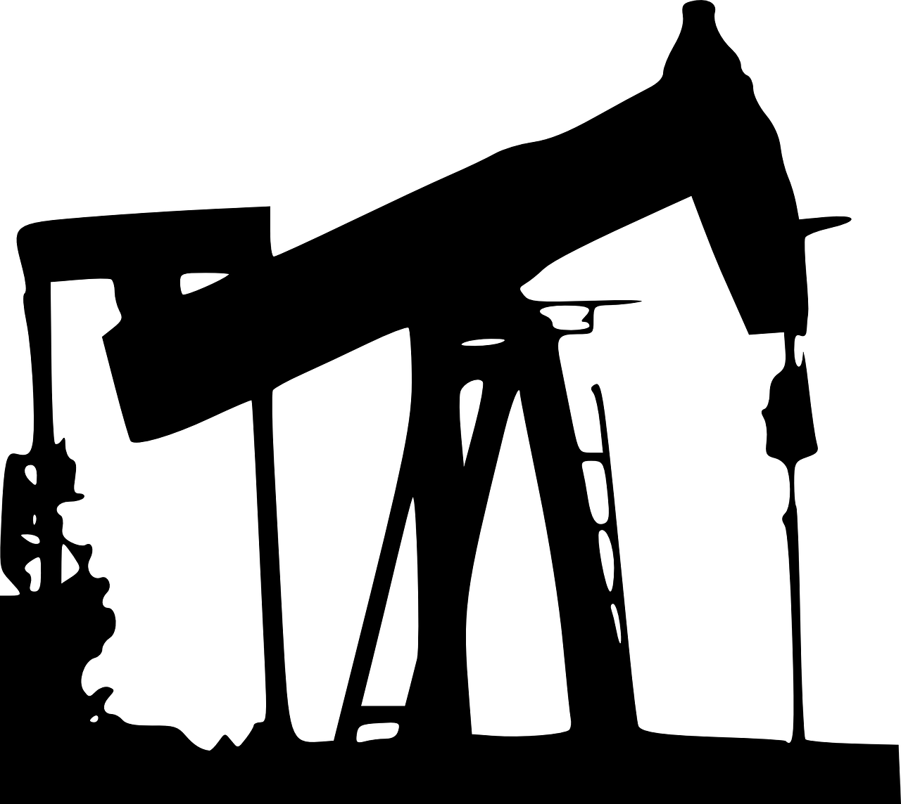Both Processes occur simultaneously. One cannot occur without the other

c:\Program Files\Common Files\Microsoft Shared\Clipart\cagcat50\AN01124_.wmf

* Single-Replacement, Combination, Decomposition, and Combustion Reactions are \_\_\_\_\_\_\_\_\_\_\_\_\_\_\_ Redox Reactions. There is a transfer of electrons in the process.
* Double-Replacement and Acid-Base Reactions are \_\_\_\_\_\_\_\_\_\_\_\_\_\_\_\_\_\_ Redox Reactions. No electrons are exchanged between the different elements, the ions are just trading partners.

**Check Your Understanding!**

*For each statement, classify the change of the underlined element as [O]xidation, [R]eduction, or [N]either:*

1. \_\_\_\_\_ Cu° → Cu2+ + 2e-
2. \_\_\_\_\_ Al3+ + 3e- → Al°
3. \_\_\_\_\_ CH4 → CO2
4. \_\_\_\_\_ NaOH + HCl → NaCl + H2O
5. \_\_\_\_\_ gaining electrons
6. \_\_\_\_\_ oxidation number increases
7. \_\_\_\_\_ Zn° + 2HCl → ZnCl2 + H2
8. \_\_\_\_\_ Mg + ½O2 → MgO

**An Introduction to Oxidation and Reduction**

**Oxidation and Reduction Movie Questions**

**Reduction**

1. Where did the term reduction come from?
2. What are two ways (or processes) to reduce metal ions?
3. Write the definition of reduction that makes the most sense to you.

**Oxidation**

1. Name two examples of oxidation.
2. Write the definition of oxidation that makes the most sense to you.

**Redox**

1. What does GER LEO stand for?
2. T/F Oxidation and reduction reactions take place together most of the time.
3. In the zinc and copper example, what was being reduced and what was being oxidized?
4. What is a reducing agent?
5. What happened with the silver tree? (wait for the copper wire demonstration before answering?

**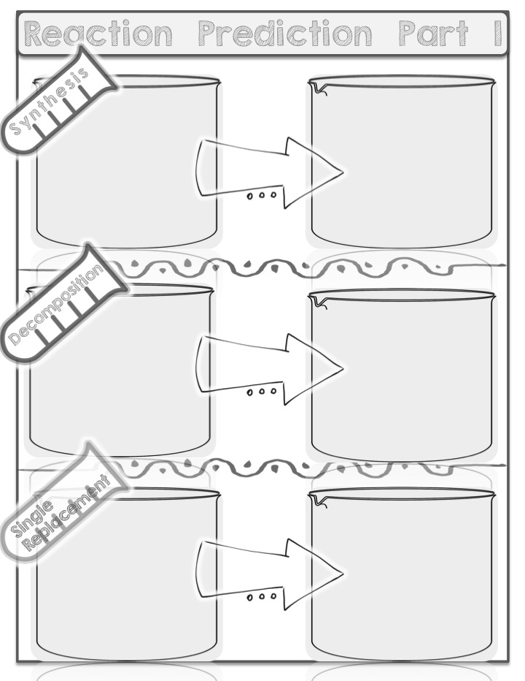**

**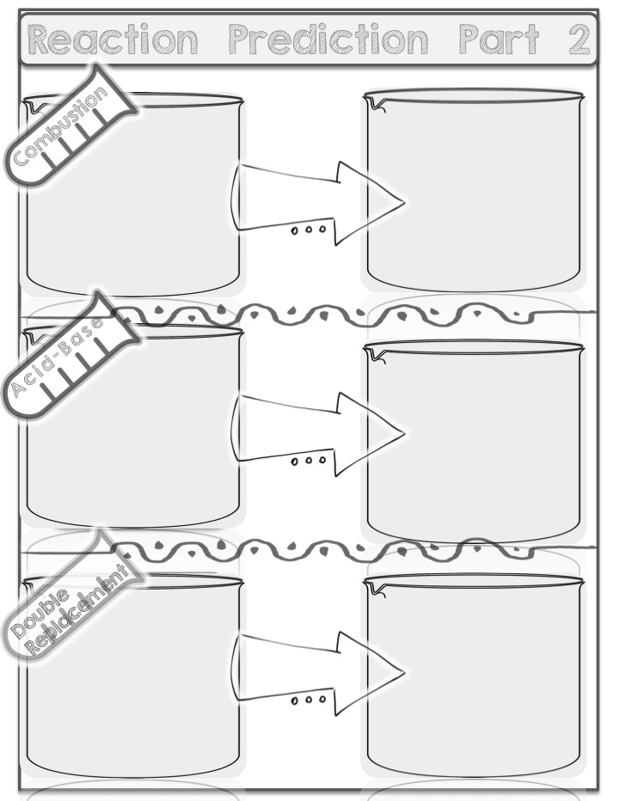**

**Related Reactivities of Metals Lab**

|  |  |  |  |  |
| --- | --- | --- | --- | --- |
| **Data Table** | | | | |
| Metal | Cu(NO3)2  Cu2+ | Mg(NO3)2  Mg2+ | Zn(NO3)2  Zn2+ | AgNO3  Ag+ |
| Cu |  |  |  |  |
| Mg |  |  |  |  |
| Zn |  |  |  |  |
| Ag |  |  |  |  |

**Analysis Questions**

1. Which metal reacted with the most solutions?
2. Which metal reacted with the fewest solutions?
3. With which of the solutions (of any) would you expect silver metal to react, if it were available to be tested? Fill your prediction in on the data table.
4. List the metals (including silver) in order, placing the most reactive metal first (the one reacting with the most solutions) and the least reactive metal last (the one reacting with the fewest solutions.
   * 1. 3)
     2. 4)
5. Refer to your “metal activity series” list in questions #4. Write a brief explanation of why the outside surface of a penny is made of copper instead of zinc.
6. a. Which of the four metals mentioned in this lab activity might be an even better choice

than copper for the outside of a penny? Why?

* 1. Why do you think that metal is not used for the coating of the outside of a penny?

1. Given your new knowledge about the relative chemical activities of these four metals:
   1. Which metal is *most* likely to be found in an uncombined or “free” state in nature?
   2. Which metal is *least* likely to be found chemically uncombined with other elements?
2. Reconsider the procedure for this lab.
   1. Would it have been possible to eliminate one or more of the metal-solution combinations and still obtain all the information needed to create the chemical activity ratings for the metals?
   2. If so, which combination(s) and why?

**Predicting Products in Chemical Reactions**

|  |  |
| --- | --- |
| **Predict the products of the reactions below and balance the equation** | **Classify the type of reaction.** |
| 1. Magnesium Bromide + Chlorine |  |
| 1. Aluminum + Iron (III) Oxide |  |
| 1. Silver Nitrate + Zinc Chloride |  |
| 1. Sodium + Hydrogen |  |
| 1. Mercury (II) Oxide decomposes |  |
| 1. Aluminum Bromide + Chlorine gas |  |
| 1. Hydrochloric Acid + Zinc |  |
| 1. Potassium Phosphate + Aluminum Nitrate |  |
| 1. Propane (C3H8) + Oxygen gas |  |
| 1. Magnesium Chloride decomposes |  |

**Predicting Products of Reactions – Part 1**

**Directions**: Find a partner. Fold your paper in half (hot-dog style). One partner put your name on one half, the other partner put your name on the other side. You and your partner will only use ***one*** pencil or pen. You will take turns writing the answer. You will not write anything until you and your partner come to an agreement. The person with the pencil/pen writes the answer, the person without the pencil/pen coaches.

|  |  |  |
| --- | --- | --- |
| **Partner 1 Name:** |  | **Partner 2 Name:** |

1. MgCO­3 🡪

Type of Rxn \_\_\_\_\_\_\_\_\_\_\_\_\_\_\_\_\_\_\_\_\_\_

3. Na2CO3 🡪

Type of Rxn \_\_\_\_\_\_\_\_\_\_\_\_\_\_\_\_\_\_\_\_\_\_

5. Cu + AlCl3 🡪

Type of Rxn \_\_\_\_\_\_\_\_\_\_\_\_\_\_\_\_\_\_\_\_\_\_

7. Ba(NO3)2+ Na 🡪

Type of Rxn \_\_\_\_\_\_\_\_\_\_\_\_\_\_\_\_\_\_\_\_\_\_

9. AlBr3 + Cl2 🡪

Type of Rxn \_\_\_\_\_\_\_\_\_\_\_\_\_\_\_\_\_\_\_\_\_\_

11. Al2S3 🡪

Type of Rxn \_\_\_\_\_\_\_\_\_\_\_\_\_\_\_\_\_\_\_\_\_\_

13. MgF2 🡪

Type of Rxn \_\_\_\_\_\_\_\_\_\_\_\_\_\_\_\_\_\_\_\_\_\_

15. Na + N2 🡪

Type of Rxn \_\_\_\_\_\_\_\_\_\_\_\_\_\_\_\_\_\_\_\_\_\_

17. Al + O2 🡪

Type of Rxn \_\_\_\_\_\_\_\_\_\_\_\_\_\_\_\_\_\_\_\_\_\_

19. Li + H2O 🡪

Type of Rxn \_\_\_\_\_\_\_\_\_\_\_\_\_\_\_\_\_\_\_\_\_\_

1. MgCl2

Type of Rxn \_\_\_\_\_\_\_\_\_\_\_\_\_\_\_\_\_\_\_\_\_\_

1. Sn(CO3)2 🡪

Type of Rxn \_\_\_\_\_\_\_\_\_\_\_\_\_\_\_\_\_\_\_\_\_\_

1. Al(OH)3 🡪

Type of Rxn \_\_\_\_\_\_\_\_\_\_\_\_\_\_\_\_\_\_\_\_\_\_

8. Na + HCl 🡪

Type of Rxn \_\_\_\_\_\_\_\_\_\_\_\_\_\_\_\_\_\_\_\_\_\_

10. NaOH + Cu 🡪

Type of Rxn \_\_\_\_\_\_\_\_\_\_\_\_\_\_\_\_\_\_\_\_\_\_

1. Zn + AlCl3 🡪

Type of Rxn \_\_\_\_\_\_\_\_\_\_\_\_\_\_\_\_\_\_\_\_\_\_

1. Li2O 🡪

Type of Rxn \_\_\_\_\_\_\_\_\_\_\_\_\_\_\_\_\_\_\_\_\_\_

1. K3N 🡪

Type of Rxn \_\_\_\_\_\_\_\_\_\_\_\_\_\_\_\_\_\_\_\_\_\_

1. Rb + O2 🡪

Type of Rxn \_\_\_\_\_\_\_\_\_\_\_\_\_\_\_\_\_\_\_\_\_\_

1. Mg + N2 🡪

Type of Rxn \_\_\_\_\_\_\_\_\_\_\_\_\_\_\_\_\_\_\_\_

**Podcast 7.5A Solubility Rules**

Review: forming ions

Ionic (i.e. salt) refers to \_\_\_\_\_\_\_\_\_\_\_\_\_\_\_ ion plus \_\_\_\_\_\_\_\_\_\_\_ ion

Usually this is a metal + non-metal or metal + polyatomic ion (e.g. NaCl, NaClO**3**, Li**2**CO**3**)

Polyatomic ions are listed on your ion card

(aq) means \_\_\_\_\_\_\_\_\_\_\_\_\_\_\_\_\_\_\_\_\_\_\_\_\_\_\_ (dissolved in water)

For salts (aq) means the **\_\_\_\_\_\_\_\_\_\_\_\_\_\_\_\_\_\_\_\_\_\_\_\_\_\_\_\_\_\_\_\_\_\_\_\_\_\_\_\_\_\_\_\_\_\_\_\_\_\_\_\_**

NaCl(aq) is the same as: \_\_\_\_\_\_\_\_\_\_\_ and \_\_\_\_\_\_\_\_\_\_\_\_\_

Acids form ions: HCl(aq) is \_\_\_\_\_\_\_\_\_\_\_ and \_\_\_\_\_\_\_\_\_\_\_\_

Bases form ions: NaOH(aq) is \_\_\_\_\_\_\_\_\_\_\_\_\_\_ and \_\_\_\_\_\_\_\_\_\_\_\_

Q - how is charge determined (+1, -1, +2, etc.)?

A –

Example:

F, Cl gain \_\_\_\_\_\_\_\_\_ electron, thus forming \_\_\_\_\_ and \_\_\_\_\_

Ca loses \_\_\_\_\_ electrons, thus forming \_\_\_\_\_

Practice with writing ions

Q - Write ions for Na**2**CO**3**(aq)

A –

Q - Write ions for Ca**3**(PO**4**)**2**(aq) & Cd(NO**3**)**2**(aq)

A –

Q - Write ions for Na**2**S(aq) and Mg**3**(BO**3**)**2**(aq)

A -

*Circle the ionic compounds that are Insoluble (i.e. circle the precipitates):*

|  |  |  |  |  |
| --- | --- | --- | --- | --- |
| MgF2 | CuSO4 | NH4Cl | Fe(OH)3 | CsF |
| AgCl | CdS | CuF2 | PbSO4 | Ba(OH)2 |
| Na2SO4 | NH4OH | Sr(NO3)2 | Hg2I2 | Na2CrO4 |
| BaCO3 | PbBr2 | CaC2O4 | HC2H3O2 | MgO |

**Predicting Products of Reactions Part 2**

**Directions**: Find a partner. Fold your paper in half (hot-dog style). One partner put your name on one half, the other partner put your name on the other side. You and your partner will only use ***one*** pencil or pen. You will take turns writing the answer. You will not write anything until you and your partner come to an agreement. The person with the pencil/pen writes the answer, the person without the pencil/pen coaches.

|  |  |  |
| --- | --- | --- |
| **Partner 1 Name:** |  | **Partner 2 Name:** |

1. HCl + Mg 🡪

Type of Rxn \_\_\_\_\_\_\_\_\_\_\_\_\_\_\_\_\_\_\_\_\_\_

3. MgCl2 + Al 🡪

Type of Rxn \_\_\_\_\_\_\_\_\_\_\_\_\_\_\_\_\_\_\_\_\_\_

1. HCl + AgNO3 🡪

Type of Rxn \_\_\_\_\_\_\_\_\_\_\_\_\_\_\_\_\_\_\_\_\_\_

7. CaCl2 + Br2 🡪

Type of Rxn \_\_\_\_\_\_\_\_\_\_\_\_\_\_\_\_\_\_\_\_\_\_

1. NaOH + H3PO4 🡪

Type of Rxn \_\_\_\_\_\_\_\_\_\_\_\_\_\_\_\_\_\_\_\_\_\_

1. AlBr3 + F2 🡪

Type of Rxn \_\_\_\_\_\_\_\_\_\_\_\_\_\_\_\_\_\_\_\_\_\_

1. Na2SO4 + BaCl2 🡪

Type of Rxn \_\_\_\_\_\_\_\_\_\_\_\_\_\_\_\_\_\_\_\_\_\_

4. H2SO4 + Zn 🡪

Type of Rxn \_\_\_\_\_\_\_\_\_\_\_\_\_\_\_\_\_\_\_\_\_\_

6. ZnCl2 + Al 🡪

Type of Rxn \_\_\_\_\_\_\_\_\_\_\_\_\_\_\_\_\_\_\_\_\_\_

8. NH4Cl + Mg(OH)2 🡪

Type of Rxn \_\_\_\_\_\_\_\_\_\_\_\_\_\_\_\_\_\_\_\_\_\_

10. Na2S + AlCl3 🡪

Type of Rxn \_\_\_\_\_\_\_\_\_\_\_\_\_\_\_\_\_\_\_\_\_\_

1. Ca(NO3)2 + Ag2SO4

Type of Rxn \_\_\_\_\_\_\_\_\_\_\_\_\_\_\_\_\_\_\_\_\_\_





# **Net Ionic Equation Worksheet**

Write balanced net ionic equations for each of the following reactions. Assume all reactions occur in aqueous solution.

1. NaCl(aq) + Pb(NO3)2(aq) → PbCl2(s) + NaNO3(aq)

2. Na2CO3(aq) + FeCl2(aq) → FeCO3(s) + NaCl(aq)

3. Mg(OH)2(aq) + HCl(aq) → MgCl2(aq) + H2O(l)

4. K2(C2O4)(aq) + CaCl2(aq) → KCl(aq) + Ca(C2O4)(s)

5. (NH4)3PO4(aq) + Zn(NO3)2(aq) → NH4NO3( ) + Zn3(PO4)2( )

6. LiOH(aq) + VCl3(aq) → LiCl( ) + V(OH)3( )

7. Na2CO3(aq) + HCl(aq) → NaCl( ) + CO2( ) + H2O( )

8. Mg(NO3)2(aq) + Na2CrO4(aq) → NaNO3( ) + MgCrO4( )

9. FeCl3(aq) + Mg(s) → MgCl2(aq) + Fe(s)

10 Zr(OH)4(s) + HNO3(aq) → Zr(NO3)4( ) + H2O( )

11. Na2SO3(s) + HCl(aq) → NaCl( ) + H2O( ) + SO2(g)

12. BaBr2(aq) + Na2SO4(aq) →

13. AgNO3(aq) + MgI2(aq) →

14. (NH4)2C2O4(aq) + Al(ClO4)3(aq) →

15. Ni(NO3)2(aq) + NaOH(aq) →

A Series of Copper Reactions

Purpose: In this experiment, you will perform a series of chemical reactions beginning with a weighed amount of copper metal. You will then recover the copper metal in the final reaction and determine the percent recovery. Since one of the basic laws of chemistry is the Law of Conservations of Mass, you should end up with the same weight of copper as you started with.

Reactions:

Cu + Cu(NO3)2 🡪 Cu(OH)2  🡪 CuO 🡪 CuCl2  🡪 Cu

Procedure:

1. **Copper (II) Nitrate from Copper**

Weight approximately 1 gram of metallic copper to 0.01 g into a 150 ml beaker and record the mass of the copper. Place the beaker on a ring stand under the hood. **CAREFULLY AND SLOWLY** add 10 ml of concentrated nitric acid (HNO3). Brown nitrogen dioxide gas (NO2) will be released, leaving a blue solution of copper nitrate. The brown NO2 is **HAZARDOUS**. If the copper does not completely dissolve, slight warming and additional acid may be required. Cool the solution to room temperature.

**The balanced reaction is:**

**Cu + 4 HNO3 🡪 Cu (NO3)2  + 2 NO2 + 2 H2O**

1. **Preparation of Copper (II) Hydroxide**

Dilute the cooled copper nitrate solution from Part A with 50ml of water. **Cautiously** add about 30ml of 6 M NaOH to produce a precipitate of copper hydroxide. The reaction is complete when no further precipitate of copper hydroxide is formed as drops of 6 M NaOH solution are added to the surface of the liquid in the beaker. The solution should test basic with litmus paper. (Use a stirring rod to transfer a small drop of solution to the litmus paper. Base turns red litmus to blue.) Add more sodium hydroxide solution if necessary. **Write the balanced equation for this reaction.**

1. **Preparation of Copper (II) Oxide**

Bring the solution of copper hydroxide up to a total volume of about 100ml with distilled water. (The volume may already exceed 100ml.) Gently simmer the solution for about five minutes with constant stirring. A black precipitate of copper (II) oxide will form as the copper hydroxide decomposes. If the precipitate does not settle, heat a bit longer. Allow the precipitate to settle and carefully decant the clear liquid being careful to lose as little of the precipitate as possible. Add about 100ml hot distilled water and repeat decantation. **Write a balanced chemical reaction for this reaction.**

1. **Preparation of Copper (II) Chloride**

Dissolve the copper by adding 15ml of 6 M hydrochloric acid (HCl) to the precipitate. Additional 1 ml amounts of HCl may be required to dissolve all the precipitate. **Write a balanced chemical equation describing this process.**

1. **Recovery of Copper Metal**

Write your name on a clean, dry watch glass, then weigh it and record the mass. To your copper solution, add at 0.5 g of aluminum foil to replace the copper. Stir the solution to increase the reaction rate. When all the copper has been replaced, the solution will be colorless or gray. Recover the copper metal by decanting off the liquid. Wash the copper metal with 50 ml of distilled water, stir, allow to settle, and decant. Remove the remaining aluminum foil and scrape any copper film off onto the watch glass. Transfer the copper to your dry, weighed, watch glass using as little water as possible. Dry the copper completely in a drying oven at 80˚C. Weigh the dish and dry copper metal. **Write a balanced chemical equation for this final reaction and calculate the percent of copper recovered.**

# **Safety Alerts**

1. Solutions contain nitric acid and/or hydrochloric acid, which is very corrosive to skin and eyes. Wash spills off yourself with LOTS of water. Neutralize spills on the lab table with baking soda.
2. Solutions are toxic; so wash your hands before you leave the lab.
3. Sodium hydroxide is a strong base and is hazardous to skin and eyes. If you get any on yourself, wash off with large amounts of water. Neutralize spills on the counter with vinegar.
4. When aluminum dissolves in the hydrochloric acid solution, hydrogen gas is produced. Make sure that no flames are present. This step should be performed in a fume hood. This side reaction should also be noted in your conclusion because it MAY influence your percent yield.
5. Wear Chemical Splash Goggles and a Chemical-Resistant Apron. You may bring your own non-latex gloves to wear during the lab if you wish.

**Prelab Questions**: Please draw safety symbols next to each step in your procedure to summarize that hazards to watch for as you complete each part of the lab. For a listing of safety symbols, please refer p. R80 in the back of your textbook. Feel free to design your own safety icon as well.

**Post-Lab Questions:**

1. Write the word equation for each of the 5 reactions.
2. Write a balanced chemical equation for each of the 5 reactions.
3. Write a net ionic equation for each of the 5 reactions.
4. Identify the type of reaction for each of the 5 reactions.

**Create a DIGITAL PORTFOLIO using Google Sites to showcase your work.**

1. Log in to Google Chrome using your school ID.
2. Type in sites.google.com
3. Click the red Create Button on the left.
4. Give your site a title using your first initial and last name.
5. 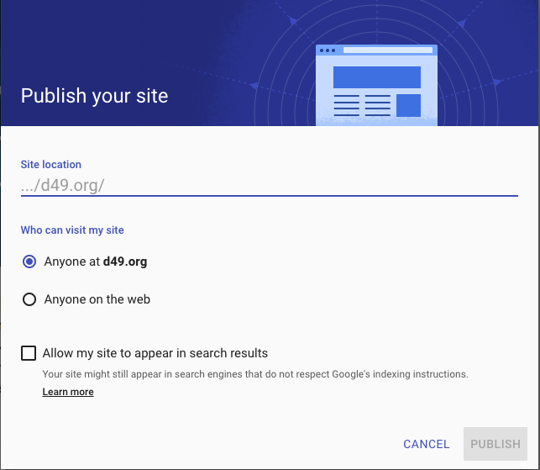Add pages by clicking the word Pages in the menu to the right. Required Pages are: Home, Personal Profile, POWER Goal, Financial Literacy, My Resume, My Social Media, Freshman Work (YEAR), Sophomore Work (YEAR), Junior Work (YEAR), and Senior Work (YEAR)
6. In the appropriate grade level page, First make a SubPage called Chemistry.
7. Use the Insert part of the menu to add a text box that says “Completed Work” and another that says “Work in Progress.”
8. Add a textbox to make a heading for this lab. Then add photos, videos, slideshows, etc. to create an interactive lab report that still meets the criteria on the rubric. When you are satisfied with your work, move it to the section called “Completed Work.”
9. Your site is AUTOMATICALLY set to be private to D49 only! Keep it that way for now please.

**Chemistry Lab Report Rubric: A Series of Copper Reactions**

|  |  |  |
| --- | --- | --- |
| **Table of Contents** | **Points Earned** | **Points Possible** |
| * Includes the title, page numbers, and date of experiment |  | 2 |
| **Title** |  |  |
| * Capitalized appropriately, relates to the experiments, underlined at the top of the lab report |  | 1 |
| **Problem Statement** |  |  |
| * Testable and clearly stated |  | 2 |
| **Variables** |  |  |
| * Independent, Dependent, Control, at least 3 constants |  | 6 |
| **Hypothesis** |  |  |
| * States what you are doing, what you predict will happen, and why you think that will happen. If…Then…Because |  | 2 |
| **Materials** |  |  |
| * A list of all materials used in the experiment |  | 1 |
| **Procedure** |  |  |
| * Write a complete, **DETAILED** procedure. |  | 3 |
| * Draw the safety icons next to each step (Pre-lab Question) |  | 5 |
| **Data** |  |  |
| Organized table that shows the data you have collected during the experiment   * Include an appropriate title * Clearly organize and label data columns and rows. Create a section for detailed observations in each step. (5points) * Write the masses of copper (before and after) and watch glass used close enough to each other to make calculation of percent yield a simple process (3points) * Data and table lines are neat and presentable (USE A RULER) |  | 8 |
| **Represent your data visually using photos or videos that are either linked or embedded on your Digital Portfolio. Be sure to set permissions on everything you embed to VIEW ONLY. Your Google Site MUST NOT be searchable!** |  | 20 |
| **Analysis** |  |  |
| * Calculate Percent Yield for your own trial and for the class average |  | 2 |
| Questions:   1. Word Equations (5) 2. Balanced Chemical Equations (5) 3. Net Ionic Equations (5) 4. Identify Reaction Type (5) |  | 20 |
| **Conclusion** |  |  |
| * Written in paragraph form (minimum of 3 paragraphs) |  | 1 |
| * Support or refute your hypothesis. Support your claim with EVIDENCE and REASONING. USE YOUR DATA- **include mass of copper and percent yield!** |  | 5 |
| * Discuss any EXPERIMENTAL error you may have had in the experiment and how these errors influenced the FINAL MASS OF COPPER. |  | 4 |
| * Discuss how to change the design to fix the errors. What further questions or investigations does this lead to? |  | 4 |
| **Discussion/Reflection** |  |  |
| * Discuss what you learned from this experiment and how it relates to what we are learning in class (Law of Conservation of Mass, Types of Reactions, Balancing Equations, Net Ionic Equations, etc) and applications in the real world (mining, medicine, technology, etc). |  | 4 |
| **Total Points** |  | 90 |

**Unit 9 Reaction Prediction Test Review**

1. What do (s), (l), (aq), and (g) stand for in a chemical reaction?
2. The activity series of metals is utilized to predict the products for which type of reaction?
3. Looking at the solubility chart and rules, which salts will form a precipitate?
4. Write the net ionic equation for Pb(NO3)2 (aq) + NH4Cl (aq) 🡪 PbCl2 (s) + NH4NO3 (aq).
5. Predict the products for C2H6 + O2 🡪
6. Predict the products for Ca + Mg(NO3)2 🡪
7. Predict the products for H2SO4 + NaOH 🡪
8. Using the equation CS2 + O2 🡪 CO2 + SO2
   1. Balance the equation.
   2. What type of reaction is this?

For those of you paying attention, you may make a 3x5 hand written note card for the test.

1. Using the equation Sn + HF 🡪 SnF2 + H2:
   1. Balance the equation.
   2. What type of reaction is this?
2. In Step B of the Series of Copper Reactions Lab, sodium hydroxide is combined with copper(II) nitrate. Write the balanced equation for this reaction, the complete ionic equation, and the net ionic equation. BE READY TO DO THE SAME FOR ANY STEP IN THE LAB!