The History of Chemistry
A golden age existed in Babylon under King Hammurabi (1792-1750 BC). He was the sixth king of the first dynast of Babylon. Due to the stability of Hammurabi’s reign, scientific thought advanced and literature flourished. Astrologers kept records of the movement of planets and made lists of stars and constellations. Known metals such as gold, silver, mercury, lead, tin, iron, and copper were matched with the brightest heavenly bodies: Sun, Moon, Mercury, Saturn, Jupiter, Mars, and Venus respectively. It is interesting to note that symbols assigned to these metals by the ancient Babylonians are used today by astronomers as the symbols for the planets.
Scientific thinking continued to develop in ancient Greek times. As early as 430 BC, the Greek philosopher, Democritus, taught that the atom was the simplest unit of matter. He thought that all matter was composed of atoms. He said that any change in matter was the result of a change in the position of atoms. He believed that atoms of each element were distinct in shape and size. For example, Atoms of water must be smooth, round balls which roll over one another, while fire could be sharp-edged and this cause pain when touched.
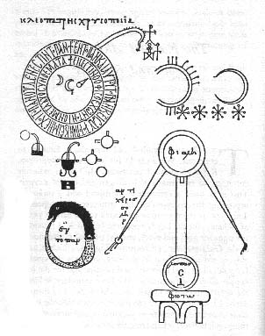
Just as true scientific thinking began to develop, it was drastically set back. The Greek philosopher who was responsible for the set-back was a fellow named Aristotle (384-323 BC). Aristotle decided that there were only 4 elements: Fire, Air, Water, and Earth. He thought that all matter was made up of these elements in varying amounts, and this matter had four properties: hot, cold, dry, and wet. He developed the idea that since all matter is consisted of four elements, and that different types of matter depended on a specific balance of the quantities of hot, cold, wet, and dry, there must be a way to change one form of matter into another by modifying its balance. The idea of changing one element to another really caught on, especially that of changing cheap metals into gold, and Aristotle’s ideas persisted for nearly 2000 years.
A group called alchemists (320BC-300AD), sprang up in the Greek-speaking world of Greece, China, India, Persia, and Egypt. The alchemists of this period were the most intellectual people of their time. Influenced by Aristotle’s ideas, alchemists explored the idea that there might be a substance which could be found of made in the laboratory that would transmute cheap metals into gold. This substance became known as the Philosophers stone. Alchemists began to devise a method for making the Philosopher’s Stone. Salt, sulfur, and mercury were some of the main ingredients they used.
Cleopatra’s Alchemy Equipment
By the 13th century, alchemy and gold making were practiced all over Europe. The famous alchemist, Raymundus Lullus, was called upon to make gold for the King of England. In 1317, Pope John XXII issued an edict against gold making. The kings of France and England followed suit, but laws could not stop efforts to transform cheap metals into gold. In the 15th century, instructions for making gold were printed and widely distributed. Unfortunately, the recipes did not work. Even so, alchemists still believed that cheap metals could be transformed into gold but thought their methods were wrong. I saw samples of gold made by 13th century alchemists in a museum in Munich. The samples looked like gold, but they have densities around 12g/ml, not 19.3 g/ml.
The alchemists were also interested in finding the elixir of life which would cure all ailments and enable people to live forever. In 1520, Philippus Aureolus Paracelsus, an alchemist who was working to find the elixir, turned from alchemy to the production of chemical remedies to cure diseases. He was the first person who used alchemy for medicinal purposes, although his cures more often killed than cure the patients. By the end of the 17th century, Aristotle’s four elements were being disproved. Robert Boyle (1629-1691) wrote the book, The Skeptical Chemist. Alchemy was dead.
The death of alchemy did not mean that chemistry got back on track immediately. The theories of early chemists were often based more on speculation than on facts. Once a theory was generally accepted, it was hard to dislodge. The Phlogiston Theory (1700-1790 AD) is a good example of a faulty theory in chemistry that was not easily given up by those who believed in it. The Phlogiston Theory dominated the chemistry community for almost 100 years.
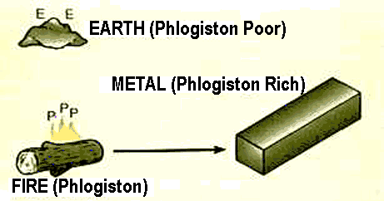
Johann J. Beecher (1635-1682) was primarily responsible for the Phlogiston Theory. He thought that when a substance burned, Phlogiston in the air around the flame was added to the substance. He thought phlogiston had no color, odor, or taste. He also believed that phlogiston weight less than nothing. It was known that when the red, powdery substance called calx of mercury was heated, it turned into mercury. Scientist of the day thought that the calx of mercury absorbed phlogiston from the air around the flame. The problem was that phlogiston would have to weigh less than nothing since the mercury produced weighed less than the original calx of mercury. Some scientists thought that if phlogiston could be isolated it could be used to levitate objects.

Calx of mercury + Phlogiston → Mercury
192 grams -32 grams? 160 grams
Joseph Priestley (1733-1804), an English clergyman, helped to disprove the Phlogiston Theory. In August of 1774, Priestley heated calx of mercury. The powder gave off a colorless gas which Priestly collected and called “dephlogisticated air” He burned different substances in the “dephlogisticated air” and noticed that they burned brighter and better than in plain air. He had discovered oxygen, but he didn’t know it. He thought the gas was just air that had lost all its phlogiston.
It was Antoine Lavoisier (1743-1794) who disproved the Phlogiston Theory. He was a brilliant Frenchman whose accomplishments are many. He figured out Priestley’s experiment and renamed “dephlogisticated air” oxygen. He realized that oxygen was the part of the air that combines with substances as they burn. Because of his work, Lavoisier is known as the Father of Modern Chemistry. On May 7, 1794, the Father of Modern Day Chemistry lost his head on a French guillotine because he was an aristocrat.
In the 1700s, a French scientist, Charles Coulomb, determined that the force of attraction or repulsion is proportional to the product of the charges (q1 and q2) and inversely proportional to the squared distance (d) between them. He found that there is a force of repulsion between liked-charged particles and a force of attraction between oppositely-charged particles.
If the charge on either of the objects is increased (or decreased), the force of attraction (or repulsion) is affected directly. For example, double the charge on one of the charged objects, and the force id doubled. If two objects that attract (or repel) each other are far apart, the force of attraction (or repulsion) is less. For example, when the distance between two charged particles is doubled, the force of attraction is reduced to ¼ the original values.
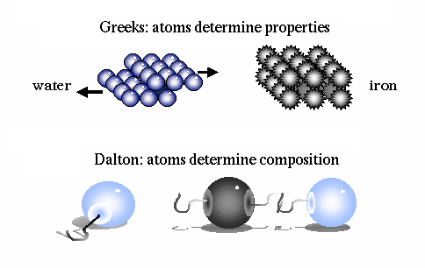
Coulomb’s ideas contributed greatly to knowledge about the atom, but first John Dalton had to steer science back to the ideas of the existence of the atom, which Democritus had proposed in 430 BC. Dalton published his Atomic Theory is 1803 which stated that all matter was composed of atoms, which were small and indivisible.
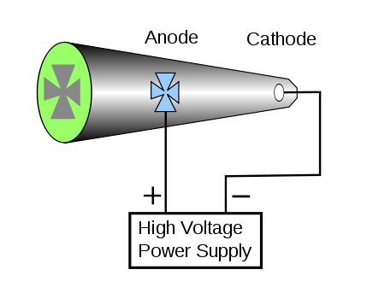
It took until 1854 for Heinrich Geissler to develop the technology necessary to find out more about the atom. Geissler was a glass blower. He made the first glass vacuum tube. The vacuum tube enabled Sir William Crookes to make a very important discovery in 1879 which led to the way to modern atomic theory. Crooks designed a glass vacuum tube which had zinc sulfide coating painted on the inside of one end, and a metal cathode embedded in the other end, and a metal anode in the shape of a cross in the middle of the tube. When the cathode was connected to a source of electricity, the zinc sulfide paint on the other end fluoresced green, and an image of the cross appeared.
Crookes concluded that there must be rays coming from the cathode which passed through the vacuum and caused the zinc sulfide of fluoresce. He called them cathode rays. The cathode rays could not penetrate the cross, and therefore the shadow of the cross appeared. Today a Crookes’ tube is called a cathode ray tube (CRT) by some and a TV by others.
Crooke’s Tube
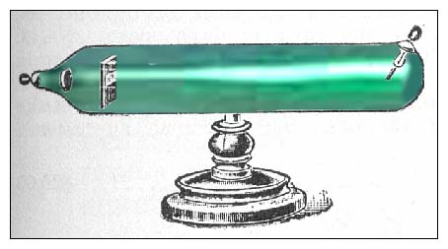
J.J Thomson (1897), a British physicist, was interested in Crookes’ work. He used a magnetic field to deflect the cathode rays in a Crookes’ tube. The cathode rays were attracted to the positive pole, and so Thomson concluded they were negatively charged. By varying the magnetic and electric fields, Thomson determined the charge to mass ratio, e/m, of the cathode ray to be 1.759 x 10^8 coulombs/grams. By using different voltages and various metals for electrodes, Thomson showed that cathode rays were the same for each metal. He concluded that “atoms of all substances contain the same kind of negative particle.” He called cathode rays electrons, symbol = e- He developed a model of the atom which showed a sphere of positively charged material with negatively charged electrons stuck in it like “raisins in pudding.” In 1906, he was awarded the Nobel Prize in physics.
Cathode Ray Tube
In 1909, Robert Millikan, an American physicist, made two horizontal plates separated by some space through which he sprayed charged oil drops. A hole in the top plate allowed one oil droplet through at a time. As the oil droplets fell through the hole, they were subjected to an electrically charged field, and the amount of charge required to keep the droplet from falling was measured. Millikan reasoned that each oil droplet, which dropped through the hole, contained a certain number of electrons. He found that all charges recorded were multiples of one minimum unit and took this to be the charge on the electron, 1.602 x 10⁻¹⁹ coulombs. (It is interesting to note that even though the charge on an electron is really 1.602 x 10⁻¹⁹ coulombs, the charge that an electron is given as 1-, which is a relative charge.) Using Thomson’s e/m ratio for electrons and the charge on the electron, Millikan was able to calculate the mass of one electron to be 0.000000000000000000000000000911 gram (9.11 x 10^-28 gram) using the formula:
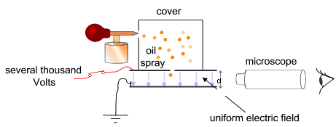
1.759 x 10⁸ coulombs/1g = 1.602 x 1602 X10⁻¹⁹ coulomb/X

In 1932, Millikan received the Nobel Prize for his work.
The discovery of electrons led to the search for positive particles, since scientists knew that atoms are electrically neutral. In 1885, Eugene Goldstein found the positive particles when he used a tube like Thomson’s filled with hydrogen gas. The positive particle had a charge equal and opposite to the electron, and was called a proton, p+. The actual mass of a proton is 1.66 x 10^-24 g, which is about 2,000 times greater that an electron. It was assigned a mass of one atomic mass unit (amu). In comparison, an electron has a mass of 0.00055 amu.
In 1895, Wilhelm Roentgen, a German physics professor, was studying the glow produced by cathode rays fluorescing in this Crookes’ tube, he darkened the room and enclosed the tube in black cardboard. He noticed that a bottle of barium platinocyanide on a shelf was fluorescing. When he increased the electrical current, the fluorescence increased, and when he turned off the electricity, the compound stopped fluorescing. Since the cathode rays were completely shielded by the cardboard and the glass of the tube, he reasoned that whatever was causing the chemical to fluoresce must have passed through the cardboard and glass. He took the tube into another room, closed the door, turned the tube on, and found that the chemical still glowed. This new form of radiation could even pass through walls. Roentgen named the rays X-rays because of their mysterious nature (“Inventive Genius” Time Life Books 52). The Victorian public was horrified that X-rays could pass through substances. Some women began bathing with all their clothes on “to escape the gaze of lecherous scientists peering at them through the brick walls of their houses. Lead-lined clothes were advertised to prevent the penetration of layers of Victorian petticoats and to protect feminine modesty.” (Pflaum 58)
One discovery frequently leads to another. Henri Becuerel (1896), a French scientist, was studying the florescence of a substance called pitchblend. The pitchblend continued to glow after being exposed to sunlight. When he read about Roentgen’s discovery of X-rays, he though the florescence might have something to do with X-rays from the sun. He exposed some pitchblend to sunlight and then placed the crystals on photographic film, which was wrapped in black paper. He thought that if the florescent glow was due to penetrating X-rays, the rays would pass through the black paper and fog the photographic film. When he developed the film, he found that the film was fogged. One cloudy day, Becquerel placed several crystals of pitchblend on photographic film and put them away in a drawer. Forgetting that he had not exposed the crystals to sunlight, Becquerel developed the film the photographic film was fogged. A flabbergasted Becguerel repeated the experiment to be sure that the crystals had really had not been exposed to sunlight. Sure enough, the plates were still fogged. The flogged photographic plate was not due to exposure of the pitchblend to sunlight was a property of the pitchblend compound.
Marie Curie isolated the elements in pitchblend and found uranium and thorium. She discovered that those elements radiated energy which she called radioactivity. In 1897, Marie Curie began a search for other naturally radioactive elements. She discovered that pitchblend was more radioactive than either the uranium or thorium contained in it. She suspected that an undiscovered radioactive element might also be present in pitchblend. The first she named radium (from the Latin for “ray”), and the other she named polonium (for Marie’s native country, Poland). For her work Madame Curie received TWO Nobel Prizes, one in physics and one in chemistry. There is a moral to this story: There are not many women represented in this history of science, but when one does get into the field, she is twice as good as any man!
In 1911, Ernest Rutherford designed an experiment which showed that here are three types of radioactivity. When he directed a radioactive source though a magnetic field and observed its path on a fluorescent screen. He noted that some of the radioactivity was deflected to the positive plate, some was deflected to the negative plate, and some was not deflected at all.
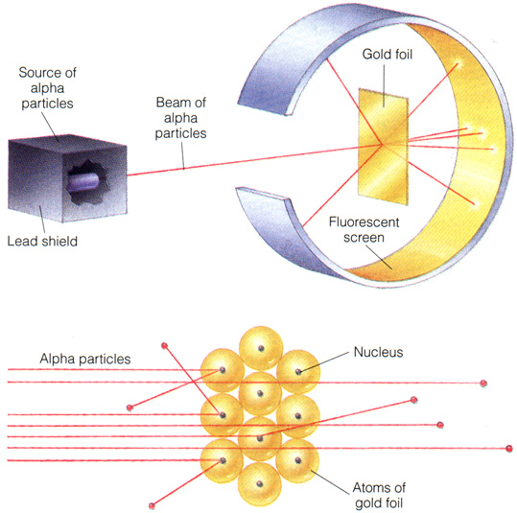
He called the three types of radioactivity alpha partials which are positive, beta particles which are negative and gamma rays which are neutral. Rutherford and his colleague Frederick Soddy decided that during radioactive decay, one element was transformed into another element. Rutherford was nervous about reporting this theory to the scientific community since it seemed to support theories of alchemy. Rutherford is reported to have said, “For heaven’s sake Soddy, don’t call it transmutation. They’ll have our head off as alchemist.”
Rutherford used alpha particles to test the theories of the make-up of atoms. He set up an apparatus where alpha partials were directed toward a piece of very thin gold foil. The gold foil he used was 1/50,000 cm thick, which was about 20,000 atoms thick. Rutherford expected most of the alpha particles to be reflected by the positively charged protons in the atoms, which he thought were spread throughout the atom. What happened was that most of the alpha particles when right through the foil without being deflected. What really amazed Rutherford was the fact that a few of the alpha particles (I in 8,000) were deflected very sharply; some even bounced back at 180 degree angles. Rutherford said this was “about was believable as if you fired a 15-inch shell into a piece of tissue paper, and it came back and hit you” (Foundations of Chemistry). Because of Rutherford’s work, Thomson’s model of the atom was thrown out and replaced with Rutherford’s model of the atom.
Rutherford’s Gold Foil Experiment
Rutherford concluded that atoms must be mostly empty space since thousands of alpha particles went through the gold foil without being deflected. Each atom must contain an extremely tiny, dense, positively charged nucleus, which is almost the entire mass of the atom, since, for an alpha particle to be deflected, the mass the alpha particle encountered must be nearly as massive as the alpha particle. He concluded that the protons were all found in the nuclei of atoms. The empty space in atoms must be taken up by electrons moving at inconceivably fast speeds around the nuclei.
Calculations base on the data collected by Rutherford show that almost the entire mass of the atom is concentrated in the nucleus of the atom. The diameter of the atom is more than 100,000 times that of the nucleus. Atoms are indeed mostly empty space. Blown up to the size of the dome of a cathedral, and atom’s nucleus would be the size of a grain of salt in the middle of the dome, and the electrons would be like the specks of dust whirling around in the huge space of the dome (The Feynman Lectures on Physics).
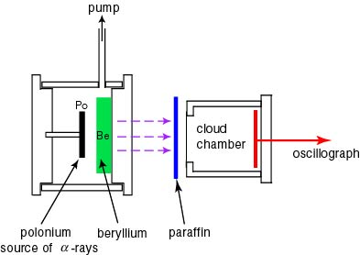
Henry Moseley (1914) used X-rays to determine the number of protons in the nucleus of each atom, but the number of protons in the nuclei dif not account for the total mass of atoms other than hydrogen. The mass of the nucleus puzzled scientist until 1932. Finally in 1932, James Chadwick discovered a particle with about the same mass as a proton but which had no charge. It was called a neutron and was assigned the symbol of n°. A neutron weighs 1.00055 amu and is found with the protons in the nucleus.
Chadwick’s Experiment
In 1932, Enrico Fermi, an Italian scientist, used neutrons to bombard many elements, producing elements of the next highest atomic number. However, when Fermi bombarded uranium with neutrons, each uranium atom split into two lighter atoms. Nuclear fission had been discovered. In 1934, Marie Curie’s daughter, Irene Curie, and son-in-law, Frederic Joliet-Curie, discovered that radioactive substances not only existed in nature but could be produced artificially when certain elements were bombarded with alpha particles. They were award the Nobel Prize in 1935.
In 1938, Enrico Fermi received the Nobel prize in physics in Stockholm, Sweden. Instead of returning to fascist Italy, Fermi went directly to the United States from Sweden. He helped to warn the United States that the Germans were far along in the development of the atomic fission reaction. Albert Einstein wrote to President Roosevelt in August 1942, and as a result, Roosevelt organized the Manhattan Project. Fermi helped to develop the first working nuclear fission reactor under the football stadium at the University of Chicago (Re-actions Sept. 1992). He used graphite as a moderator in his nuclear reactor to slow down the neutrons enough to react with the uranium. He could have used heavy water instead. Heavy water was produced in Norway as a result of hydroelectric installations. It was Germany’s invasion of Norway and the all-out collection of Norway’s heavy water in the 1940s that convinced the United States scientists that the Germans were attempting to make a uranium bomb.

